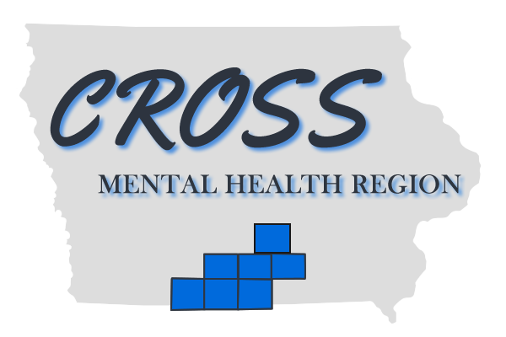

FOR IMMEDIATE RELEASE
August 1, 2023

MEDIA CONTACTS:
Darci Alt
CEO, Heart of Iowa Community Services
Darci.Alt@dallascountyiowa.gov
515.993.5869

Rachel Cecil
Regional Director of Operations, Heart of Iowa Community Services
Rachel.Cecil@dallascountyiowa.gov
641.828.2238, ext. 3870

Laura Sprague, APR
Sr Communications Specialist, Trilix
lsprague@trilix.com
515.770.6206

Heart of Iowa Expands Services, Expertise to CROSS Region
New partnership strengthens approach to mental health services, crises in Iowa

(Knoxville, Iowa) — August 1, 2023 — Heart of Iowa Community Services (HICS), a leader in connecting Iowans with mental health support and stability services, is now expanding its programming into the six-county CROSS Mental Health Region, serving residents in Clarke, Decatur, Lucas, Marion, Ringgold and Wayne counties.

Heart of Iowa CEO Darci Alt said the opportunity to work with CROSS comes at a time when there is more need than ever before to ensure Iowans receive mental health-related support and response that addresses their needs.

“Whether a person is facing an incarceration or needing to find stability in their lives after a crisis, Heart of Iowa has worked to create strong programs that get at the root of the issues a person faces,” Alt said. “When we can work together with law enforcement agencies, mental health providers and county-based human service agencies, we see success for all. Partnering with CROSS will expand our model to southern Iowa and serve even more Iowans in need.”

As of July 1, 2023, the CROSS governing board voted to approve HICS as the new manager for the CROSS region. Both are part of Iowa’s Mental Health and Disability Services (Iowa MHDS), which has 13 regions clustered by county throughout the state. Each region serves as a resource for residents in their respective area. Rachel Cecil, regional director of operations for HICS, said working with HICS will provide the stability and guidance the region seeks to accurately meet the needs of its citizens.

“Our board of directors and staff feel this shift in management will position the region in the best manner possible in anticipation of the changing landscape of health and human services across the state of Iowa,” said Cecil. “CROSS strongly feels that working proactively to align services operations and functions of the region with Heart of Iowa will be beneficial in a multitude of ways.”

As leadership from HICS begin to work closely with CROSS programming, one of the first steps will be streamlining administrative operations and accountability. As a six-county region, Cecil explained there were multiple different employers of records and variances in procedures. The new agreement will bring everything together in one functional manner.

The major goal of the agreement — and an area where HICS leadership has excelled — is developing a continuum of care and collaboration between law enforcement agencies, local hospitals, regional service coordination, crisis providers, Certified Community Behavioral Health Clinics and Medicaid partners.

Another program CROSS sees as a benefit to residents in their area is the CIT Co-responder Program. Here, a dedicated police officer and mental health professional pair responds to mental health-related calls from dispatch during their regularly scheduled shift. Each situation is approached through de-escalation techniques, with an overall goal of jail diversion.

In successful mental health jail diversion programs, people in need are less likely to be sent to jail because they are evaluated and connected to services that assist them in moving forward with life.

“While CROSS regularly works with local law enforcement partners, HICS has the experience and relationship-building skills to introduce a co-responder model in this area,” said Cecil. “This is a benefit to all, including first responders, mental health professionals and community members in need.”

To learn more about CROSS Mental Health Region, visit their website at CrossMentalHealth.org. Assistance related to mental health needs is available 24 hours a day, seven days a week at 988 or 855-581-8111.
# # #

