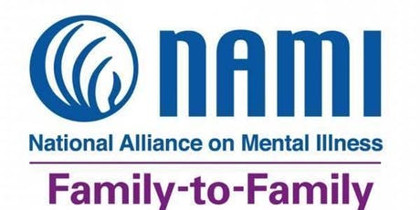 | For family, significant others and friends of people with mental health conditions.This is a designated evidenced-based program. This means that research shows the program significantly improves the coping and problem-solving abilitites of the people closest to a person with a mental health condition.  Taught by NAMI-trained family members who have been there, and includes presentations, discussions and interactive exercises.

Join Matthea and April for NAMI Family-to-Family. This free 8-week educational program will be offered 100% virtual via ZOOM.

October 1, 2020 through November 19, 2020 every Thursday evening from 5:30 – 8:00 pm
Course Schedule: |  | 5:30 pm – 8:00 pm @ ZOOM
10/01/2020 | Class 1 | Introduction to NAMI Family-to-Family
10/08/2020 | Class 2 | Understanding Mental Health Conditions and Preparing for Crisis
10/15/2020 | Class 3 | Getting a Mental Health Diagnosis and Sharing Our Stories
10/22/2020 | Class 4 | Overview of Mental Health Conditions
10/29/2020 | Class 5 | Treatment Options
11/05/2020 | Class 6 | Communication Skills and Problem Solving
11/12/2020 | Class 7 | Empathy and Recovery
11/19/2020 | Class 8 | Moving Forward
Pre-Registration is required in order to ensure we have the appropriate resources available.

We will mail your class materials to the address below.
Name of Participant:
Phone #: |  |  | Are Texts Ok?
Mailing Address:
Email Address:
Tell us about your loved one:
Relationship to You:
Age:
Diagnosis (If diagnosed):
Send completed registration forms to:
April Cornelison
307 McKimber Street
Pleasantville, Iowa 50225

