Request for Proposal
Supported Employment Fidelity Review

Table of Contents
- Information and Background
- Purpose
- Eligibility Information
- Application and Submission Information
- Scope of Work
- Funding
- Proposal Evaluation Criteria
- Decision Process
- General Procurement Information

Funding Opportunity Title | Supported Employment Fidelity Review
Release Date of Proposal | August 1, 2020
Due Date for Applications | September 15, 2020
Estimated Number and Type of Awards | Two
Anticipated Funding | $5,000
Cost Sharing / Match | $0
Project Period/Period of Performance | 10/1/2020-6/30/2021

A. Information and Background
State Program

Iowa Code 2015, Chapter 331, Part 6, Mental Health and Disability Services-Regional Service Systems charges designated mental health and disability services regions to develop core and core plus mental health services including crisis services.

Local Program
Iowa Code 2015, Chapter 331, Part 6, Mental Health and Disability Services-Regional Service Systems charges designated mental health and disability service regions to develop evidence-based community supports, core and core plus services to advance the treatment and inclusion of individuals with persistent mental illness in their communities.

B. Purpose
It is the purposeof this Request for Proposal (RFP) to solicit a respondent(s) to engage in a collaborative partnership with the Region to conduct an external fidelity review of their Supported Employment program.

C. Eligibility Information
The following are the minimum requirements the proposer, hereafter referred to as the Agency, must demonstrate in order to continue in the proposal review process. AGENCIES THAT FAIL TO MEET THESE REQUIREMENTS WILL NOT BE REVIEWED

- The Agency must be able to provide services in compliance with PL 101-645 Title V, Subtitle B; Part 438 Balanced Budget Act (BBA); 45 CFR Health Insurance Portability and Accountability Act (HIPAA), Pacts 160 and 164; the Iowa Code section 249A.4 Chapters 77,79; Iowa Administrative Code (ARC 441-Chapter 24(225C); Iowa Code Chapter 135G; Iowa Administrative Code 481 Chapter 71; and the CROSS Region Management Plan and its revisions.

- The Agency must be a current contractor of the CROSS provider network and offer Supported Employment services.

- The Agency must submit with the proposal a transmittal letter signed by an individual authorized to legally bind the organization to fulfill the RFP requirements. The letter will include a statement indicating the legal entity, licensure, and tax status of the organization(s) responding to the RFP, and the name, title, mailing address, telephone, and fax number of the individual(s) to be contacted by CROSS during the proposal review and selection process.

- The Agency must be able to provide requested documentation and participation in required interviews and processes of the fidelity review.

- Include a statement attesting that the grant funding will not be used to supplant any existing crisis or mental health programming.

Debarment, Suspension, Ineligibility, and Voluntary Exclusion Certification
The prospective recipient certifies, by submission of this proposal, that neither it nor its principals is presently debarred, suspended, proposed for debarment, declared ineligible, or voluntarily excluded from participation in this transaction by any state or federal department or agency.

Cost Sharing/Matching
This application does not require a cost share or match funds.

Other
Applications that exceed the ceiling amount will be considered non-responsive and will not be considered for funding under this notice.
Any application that fails to satisfy the deadline requirements referenced in H. Decision Process will be considered non-responsive and will not be considered for funding under this notice.
Note: Multiple applications from an organization are not allowable.

Program Requirements
Iowa Administrative Code 441-Chapter 25.5(3) Regions must have evidence-based practices that the region has independently verified as meeting established fidelity to evidence-based service models including, but not limited to, assertive community treatment or strengths-based case management; integrated treatment of co-occurring substance use and mental health disorders; supported employment; family psychoeducation; illness management and recovery; and permanent supportive housing.

D. Application and Submission Information

- Each Minimum Qualification and item in the Evaluation Criteria will be addressed. Organize responses in the same order as the items are show in the RFP

- Responses will be prepared simply and economically, providing a straightforward and concise, but complete and detailed description of your ability to meet the requirements outlined in this document. Emphasis will be on the completeness of content.

- The response must use standard size type (a font size of no less than 12 points) and must be on 8.5 x 11 inch white paper.

- Responses will contain, in the following order:

- Proposer Eligibility and Qualifications
- Scope of Work
- Proposed Budget
- Proposed Budget Narrative

- Scope of Work

Purpose: Completion of external Supported Employment fidelity review and Quality Improvement.

Scope: Awarded respondents will agree to fully participate in the following in partnership with the Region fidelity review team that is outlined as agency and region responsibilities.

Agency Responsibilities:

  - Agency agrees to the completion and submission of the SAMHSA Supported Employment Readiness Assessment.
  - Agency agrees to the completion and submission of General Information elements required for the fidelity review;
    - Roster of employment specialists (including role and FTE)
    - Roster of Supported Employment consumers served by each specialist (ie. Caseload for each specialist)
    - Roster of Supported Employment consumers who left in the last six months (include reason they left the program)
    - Total number served in the past six months
    - Copy of brochure or mission statement.
    - Copy of policy and procedures, blank referral form, intake form, vocational profile, individual employment plan, copy of screening tool, supervision logs and other necessary forms.
    - Copy of curriculum used to train staff in the model.
    - Copy of Quality Assurance and Quality Improvement procedures.
    - 10 sample chart randomly selected.
  - Agency agrees to participation in supervisory staff and employment specialist interviews conducted by the Region fidelity review team.
  - Agency agrees to the observation of team meeting/supervision sessions by the Region fidelity review team.
  - The Agency will participate in an exit meeting and Quality Improvement process discussion to further the implementation and adherence to the SAMHSA fidelity model of Supported Employment and Individual Placement and Supports (IPS)

Region Responsibilities:

- The Region fidelity review team will conduct documentation and chart reviews of elements provided by the agency as described in elements 1&2 in the section above.
- The Region fidelity review team will conduct interviews of agency staff related to the supported employment program using the SAMHSA fidelity questionnaire as well as an onsite observation of a team meeting/supervision session.
- The Region fidelity review team will conduct consumer and/or family member interviews using the SAMHSA fidelity questionnaire. Interviews will be anonymous and specific to the supported employment program.
- The Region will provide an objective consensus rating and reporting identifying the level of fidelity to the SAMHSA Supported Employment model.
- The Region will conduct an exit interview with the Agency and Quality Improvement process discussion to further the implementation and adherence to the SAMHSA fidelity model of Supported Employment.

Service Component Description:
Iowa Administrative Code 441-Chapter 25 defines components related to supported employment programs as follows.

“Individual supported employment” means services including ongoing supports needed by an individual to acquire and maintain a job in the integrated workforce at or above the state’s minimum wage. The outcome of this service is sustained paid employment that meets personal and career goals.

“Individual Placement and Supports” means a model of supported employment for people with serious mental illness. IPS supported employment helps people living with behavioral health conditions work at regular jobs of their choosing.

“Job development” means services that assist individuals in preparing for, securing and maintaining gainful, competitive employment. Employment shall be integrated into normalized work settings, shall provide pay of at least minimum wage, and shall be based on the individual’s skills, preferences, abilities, and talents. Services assist individuals seeking employment to develop or re-establish skills, attitudes, personal characteristics, interpersonal skills, work behaviors, and functional capacities to achieve positive employment outcomes.

“Supported employment” means an approach to helping individuals participate as much as possible in competitive work in integrated work settings that are consistent with the strengths, resources, priorities, concerns, abilities, capabilities, interests, and informed choice of the individuals. Services are targeted for individuals with significant disabilities for whom competitive employment has not traditionally occurred; or for whom competitive employment has been interrupted or intermittent as a result of a significant disability including either individual or group supported employment, or both, consistent with evidence-based practice standards published by the Substance Abuse and Mental Health Services Administration.

The following is an excerpt from SAMHSA building your program toolkit regarding “What is Supported Employment”.
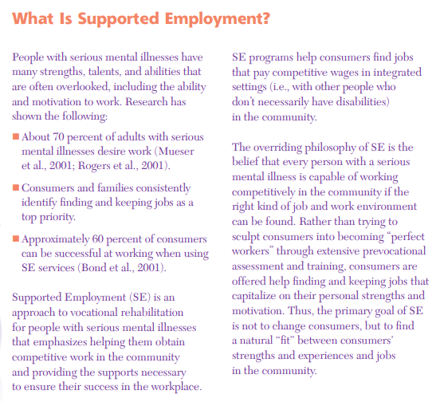
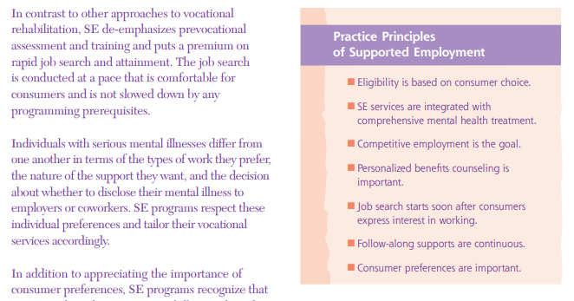
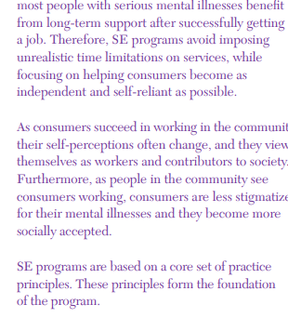

F. Funding
The total amount of funds available over the project period of this grant is $5000.00 per awarded contract.

The project period for this grant shall run from October 1, 2020 through June 30th 2021.

Funds will be released upon completion of the fidelity review. The region requires 25% of funds to be utilized for direct payments to staff and 25% of funds to be used for training or other initiatives that will directly benefit the Supported Employment programming.

G. Proposal Evaluation Criteria

A total of 50 points will be awarded for the written response to the RFP in the following categories:

- Agency Qualifications (10 points)
- Services to be Provided (10 points)
- Collaboration (10 points)
- Budget Detail and Narrative (20 points)
- Optional Interview (50 points)

The Agency must demonstrate throughout the proposal commitment to the practice principles of supported employment. While the region identifies that not all agencies may have implemented the fidelity model, the purpose of this project is to identify a baseline and work towards full implementation of fidelity.

Agency Qualifications
Points in this category will be awarded based on the extent to which the Agency can demonstrate experience with implementation, provision and quality assurance and improvement with a supported employment program.

The proposal should describe and document the Agency's experience with and/or strategy for:
- Providing supported employment services to adult persons with mental illness, substance abuse, disability and individuals with complex needs who are interested in working.
- Developing employment services that meet state or national accreditation standards and reimbursement eligibility through Medicaid, Medicare and other third parties.
- Providing mental health, substance abuse, or other health related services with in the CROSS MHDS Region area.
- Experience in providing other evidenced-based practices including those evidence-based practices that require ongoing fidelity measurement.
- Experience in implementation and provision of Individual placement and supports.

Services to Be Provided
Referring to the scope of work as well as the responsibilities sections of this document explain in detail how the Agency will partner in collaboration with the Region to meet the end goal of this project, while being succinct, self-explanatory, and well organized so reviewers can understand the proposed plan.

Collaboration
Describe the Agency's plan for developing collaborative working relationships with the Region Fidelity Review team as well as experience in developing relationships with businesses and employers.

Budget Detail and Narrative
- Provide a Line Item Budget for the awarded funds, specify the amounts to be allocated for staff payment, training and other identified line items. Identify by name specific training(s) that will be invested in.

- Specify the source and amount of any funds and resources to be used from other sources.

Optional Interview
If a selection cannot be made based on the written proposal evaluation and the agency performance rating alone, CROSS Administration shall elect to interview the top two or more Agencies. Interviews will be worth 50 points. If interviews are conducted, the final award would be based upon the total points awarded for the written evaluation, Agency performance and the oral interview. (50)

H. Decision Process
Only those proposals that meet the minimum requirements stated in Section C. will be reviewed by panel of raters selected by the CROSS Administration. The responses will be rated according to the points specified in Evaluation Criteria above.
It is tentatively scheduled that within two weeks after the response deadline, the rating panel will meet. At that meeting, the panel will:
- Review each member's independent ratings of the responses
- Tabulate scores for each proposal
- Generate for those tabulated scores a final ranking.

PROPOSED SCHEDULE - SUBJECT TO CHANGE
Date | Action
August 1, 2020 | Release of RFP
August 21, 2020 by 4 PM | Deadline for Question Submittal
September 1, 2020 by 4 PM | CROSS Question Response Released
September 30, 2020 by 4 PM | Submission Deadline
September 15, 2020 | Evaluation of written Proposals Interviews (if conducted)
September 29, 2020 | RFP awarded
September 29, 2020 | Contract Negotiation
October 1, 2020 | CROSS begins contracting with Agency
October 1, 2020 through June 30,2020 | Agency and CROSS work collectively for completion of the fidelity review utilizing the SAMHSA toolkit and Quality Improvement process.

I. General Procurement Information
RFP Amendments
CROSS may, at any time before execution of a contract, amend all or any portion of this RFP. CROSS will mail any RFP amendments to you. If there is any conflict between amendments or between an amendment and the RFP, whichever document was issued last in line shall be controlling.

Retraction of this RFP
CROSS is not obligated to contract for the services specified in this RFP. CROSS reserves the right to retract this RFP in whole, or in part, and at any time without penalty.

Rejection of All Proposals
This RFP does not obligate CROSS to contract for services specified herein.
Aspects of this proposal may change as the Iowa Legislature reviews and passes further mental health legislation.

Most Favorable Terms
Cross reserves the right to make an award without further discussion of the proposal submitted. Therefore, the proposal should be submitted initially on the most favorable terms that the proposer can put forward. There will be no best and final offer procedure. CROSS reserves the right to contact a bidder for clarification of its proposal.

The proposer should be prepared to accept this RFP for incorporation into a contract. Contract negotiations may incorporate some of or the entire proposal. It is understood that the proposal will become a part of the official procurement file on this matter without obligation to CROSS.

