RFI Crisis Stabilization Community Based Services Q&A
Please note responses from the region does not supersede the guidance or requirements set forth in legislation or Iowa Code. Please refer to Chapter 24 and Chapter 25 as well as the Iowa Department of Human Services Crisis Response Services Provider Manual for full detail.
Question 1: Can the program be utilized as a hospital “step down” option as well as providing crisis stabilization supports? It is unknown if the IME or MCO’s will approve funding for the service as a step down, it is designed to be for a crisis response. The region may take under consideration funding this service as a step down or bridge into other community based services. The region would encourage applicants responding to the RFI to set forth in the response a full budget that would include anticipated “bridge” or “step down” funding as well as a narrative outlining the usage and benefits of using a crisis services as a step down model as well.
Question 2: How will the screening, referral and authorization (gatekeeping) process work?
Referrals: The region anticipates referrals may come from a variety of sources to include but not be limited to; region staff, emergency departments, ACT Team, Access Center, community based providers as well as family and self referral.
Screening/Eligibility:
24.38(1) Eligibility. To be eligible, an individual must:
a. Be determined appropriate for the service by mental health assessment;
and
b. Be determined not to need inpatient acute hospital psychiatric services.
25.4(2)b. An individual who has been determined to need CSCBS shall receive face-to-face contact from the CSCBS provider within 120 minutes from the time of referral.
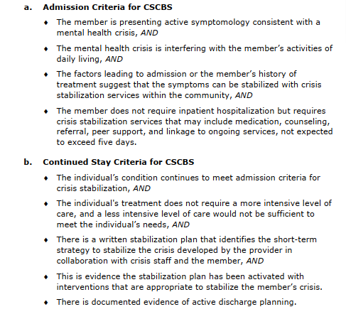
Authorization process through the region would follow the current funding request process through the Client Services Team Lead. IME FFS or MCO covered individuals may required a preauthorization or notification process prior to funding. The provider would implement internal policy and procedures adhering to Chapter 24 accreditation that would include but not be limited to screening and admission.
Is there a planned process for medical clearance prior to referral? Medical clearance is not required for CSCB.
Can telepsychiatry and remote monitoring be utilized to enhance staffing? Yes, it may be used to enhance staffing but not in place of the required face to face contacts.
24.38(2) Staffing requirements.
a. A designated director or administrator is responsible for the management and operation of the CSCBS.
b. At least one licensed nurse practitioner, physician assistant, or psychiatrist is available for consultation 24 hours a day, 365 days a year.
c. Mental health professionals with expertise appropriate to the individual’s needs provide services.
d. Contact between the individual and a mental health professional occurs at least one time a day.
e. Additional services are provided by crisis response staff at a minimum of one hour per day, including, but not limited to, skill building, peer support or family support peer services. The goal of CSCBS is to stabilize the individual within the community. CSCBS is designed for voluntary services for individuals in need of a safe, secure location that is less intensive and restrictive than an inpatient hospital.
f. Crisis response staff must be awake and attentive 24 hours a day
Does the Regional team have a sense of how many beds may be needed?
The region is interested in building capacity and access for the service as described below.
441—24.38(225C) Crisis stabilization community-based services (CSCBS). The goal of CSCBS is to stabilize the individual within the community. CSCBS is designed as a voluntary service for individuals in need of a safe, secure location that is less intensive and restrictive than an inpatient hospital. Individuals receive CSCBS services including, but not limited to, psychiatric services, medication, counseling, referrals, peer support and linkage to ongoing services. The duration for CSCBS is expected to be less than five days.
Crisis stabilization community-based services are short-term services designed to de-escalate a crisis situation and stabilize an individual experiencing a mental health crisis, provided where the individual lives, works or recreates. CSCBS is a voluntary service for individuals in need of a safe, secure location that is less intensive and restrictive than an inpatient hospital. The goal of CSCBS is to stabilize the individual within the community
The region views this capacity as slots rather than beds as this would not be a facility based service. Based on preliminary estimates the region anticipates 10-15 slots per month at the inception of the program with potential to increase as awareness and availability of the service increases across the region.
How will payment be made in the event of less than full occupancy?
The region anticipates grant funding for start up costs as well as funding to “ramp up” services and build a referral network and presence to increase utilization. The region may entertain a phasing out approach across fiscal years similar to grant funded proposals the region has supported in the past. The region would encourage applicants responding to the RFI to set forth in the response a full budget that would include potential short falls from Medicaid and other third party reimbursements and any potential region funds to continue to sustain operations.
Is admission only limited to Medicaid participants? If not, will the Region pay for non-Medicaid eligible participants?
The service would not be limited to Medicaid covered individuals. Based on preliminary estimates the region anticipates 90-95% of individuals accessing this service will be Medicaid funded. The region may entertain funding a set number of Medicaid slots, similar to other start up programs the region has funded in the past. The region would encourage applicants responding to the RFI to set forth in the response a full budget that would include potential short falls from Medicaid and other third party reimbursements and any potential region funds to continue to sustain operations.

