Clarke County Prevent Child Abuse Council
&
CROSS MHDS Region
will be hosting a
Connections Matter Presentation
Thursday, March 12, 2020
9:00-11:30 AM
Osceola Public Library
300 S. Filmore
Osceola, IA 50213

Light refreshments will be provided by the
Clarke County Prevent Child Abuse Council!

Space is limited! To reserve your spot please call or text 641-414-7105
or you can email the council at: clarkepca@yahoo.com

Every day connections are more important than we ever believed. Science tells us that relationships have the power to shape our brains. Relationships help us learn better, work better, parent better. When we experience tough times, they help us heal. With each connection, we develop a healthier, stronger community. Everyone has the power to make a connection with someone. Find out how your business can make a connection that helps our community!
During the presentation you will receive:
- Better understanding of trauma, brain development, resilience, and health - how these topics relate to one another and how understanding them can help your employees, co-workers, and customers
- Action planning and next steps for how you can make a difference
- Strategies for increasing and improving your own connections
- Meeting other community members and building your network
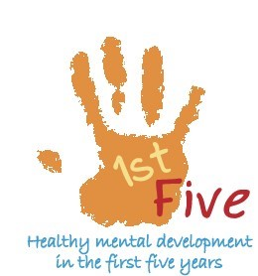
- Tools for strengthening both personal and community resilience
Clarke County
Prevent Child Abuse Council
641-342-3724
Find us on Facebook!
