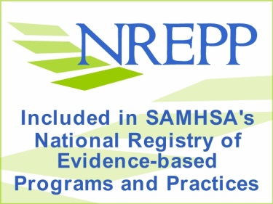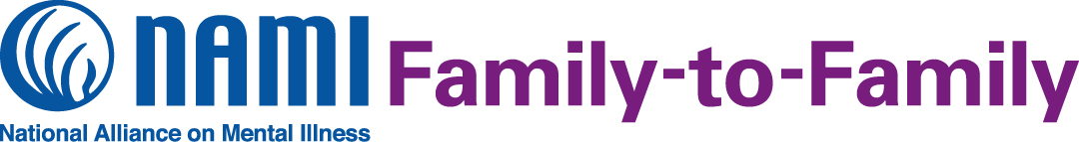

**What is the NAMI Family-to-Family Education Program?**

NAMI Family-to-Family is a free, 12-session education program for family, partners, friends and significant others of adults living with mental illness. The course is designed to help all family members understand and support their loved one living with mental illness, while maintaining their own well-being. The course includes information on illnesses such as schizophrenia, bipolar disorder, major depression and other mental health conditions. Thousands of families describe the program as life-changing. The program is taught by trained teachers who are also family members and know what it is like to have a loved one living with mental illness.

We are offering the NAMI Family-to-Family Education Program beginning January 16, 2020 through April 2, 2020. It will be held on Thursdays at 5:30 – 8:00 PM at the Knoxville Library.

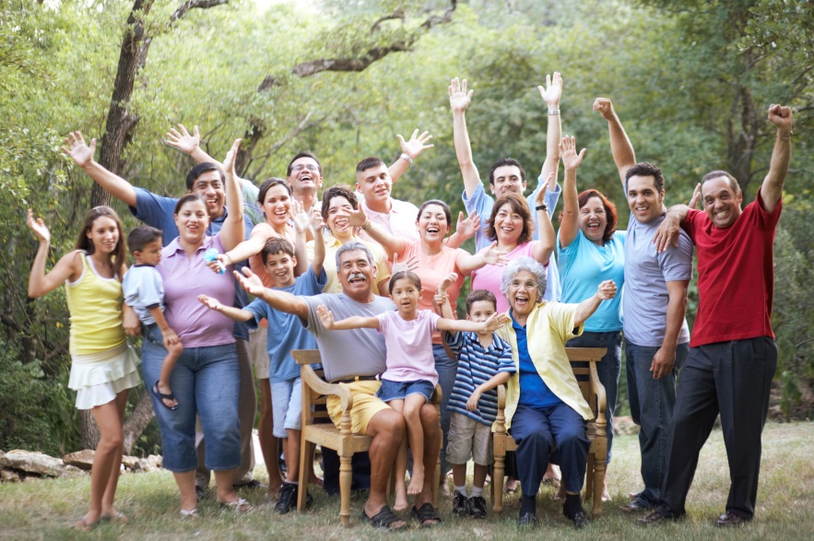

**Participant Perspectives**

“This course overall was the single most, without a doubt, helpful and informative thing ever offered in all my years searching for answers… It has helped me to understand better and communicate more effectively with my brother.”

“The course has helped me to realize that my son is still inside the body that is often times hidden by the mental illness and that I am not alone in this.”

**Contact us to register for this NAMI Family-to-Family class!**

**April & Reuben Cornelison**

**Email:** [**April.cornelison14@gmail.com**](mailto:April.cornelison14@gmail.com)

**April: 515-314-9459**

**Reuben: 515-418-6364**

**(Please leave a message and we will get back to you ASAP. Thank you)**

**Visit our Facebook Page for more information or to register.**

<https://www.facebook.com/Family.Support.Marion.County>

**About NAMI**

NAMI, the National Alliance on Mental Illness, is the nation’s largest grassroots mental health organization dedicated to building better lives for the millions of Americans affected by mental illness. NAMI is dedicated volunteers, members and leaders work tirelessly to raise awareness and provide essential education, advocacy and support group programs for people in our community living with mental illness and their loved ones.